Chen-Yu Chang (C4)

Yixiu Zhu(C3)

Zhang Chi Lu (C4)

Filename:

The program is our original work.

Signature:

___________________

___________________

___________________

Background & Explanation:

Traveling is the ways in which we see the world, and how we want to experience different styles of lives. This is the reason that why traveling is so popular. The travel and tourism's direct industry gross domestic product (GDP) represents nearly 3.1% of global GDP and it still has the capability of generating more values (i.e. creating employment, enhance regional cooperation, etc.) However, travelers always have problems finding their ideal destination. Our project is to help these travelers to find their ideal country to travel to.

Unfortunately, as the world's air condition is worsening due to industrialization, traveling can be more challenging especially for people who suffer from pulmonary conditions. Moreover, if you are worried about your lungs, the air quality of the location to which you are traveling can make a big difference to travelers overall traveling enjoyment. Our project imbeds datasets of PM2.5 amounts in varied countries and lets users choose whether they favor to traveling in countries with better air cleanness or not.

Furthermore, the popularity of traveling destinations is another essential prerequisite for an overall enjoyable traveling experience. More people traveling to a place, more travel reviews will be available and travel routines will be explored. Our project also includes dataset for overnight travelers in varied counties and let users choose whether they favor to traveling in countries with higher popularity or not.

The source link:

[https://stats.oecd.org/index.aspx#](https://stats.oecd.org/index.aspx)

Requirement fulfilled:

1. Reading 2 datasets. (On lines 31-33 and 49-51we reads into 2 datasets to a file using self-created function “pmwant” and “tourwant”. The data set is from the file “PM25.csv” and “tourism.csv”.
2. Analyzing 2 datasets. (On lines 35-48 and 53-66 we analysis 2 datasets and program to filter the data we actually want to present. We selected the “Mean population exposure to PM2.5” and “Overnight visitors (tourists)”. On line 68-102 we sort 2 data set to reorganize them. On line 104-132 we finally sort the result with addition of weight determined by slider in UI. Lastly, we store our results into a structure.
3. The fprintf function is applied to store our data into file “Top10.m”(This is on line 161-165.).
4. We also have our chart created on the UI for a more effective information delivery. (On lines 176 -185 and 196-205, we created the chart functions and linked it to our user control interface.)

Instructions:

The general functions of our application:

1. To suggest 10 best countries to travel in the starting screen (It is the overall mean derived after we implement the PM2.5 data as well as the overnight tourism data in year of 2016).
2. To let user to choose the year they want the data to be ranged
3. To let users use the slider to choose their favor side (Air cleanness or popularity).
4. Show the new suggestions for 10 best countries to travel to according to users’ preference.
5. Let users click button click buttons of “Air cleanness” or “Popularity” to show the exact values in chart.

Step by step instructions:

1. The default starting window:

The picture below is the UI window for our application. It has three sectors: the chart sector is on the upper left, the suggestion window is on the upper right and the user input window is on the lower portion of the picture.

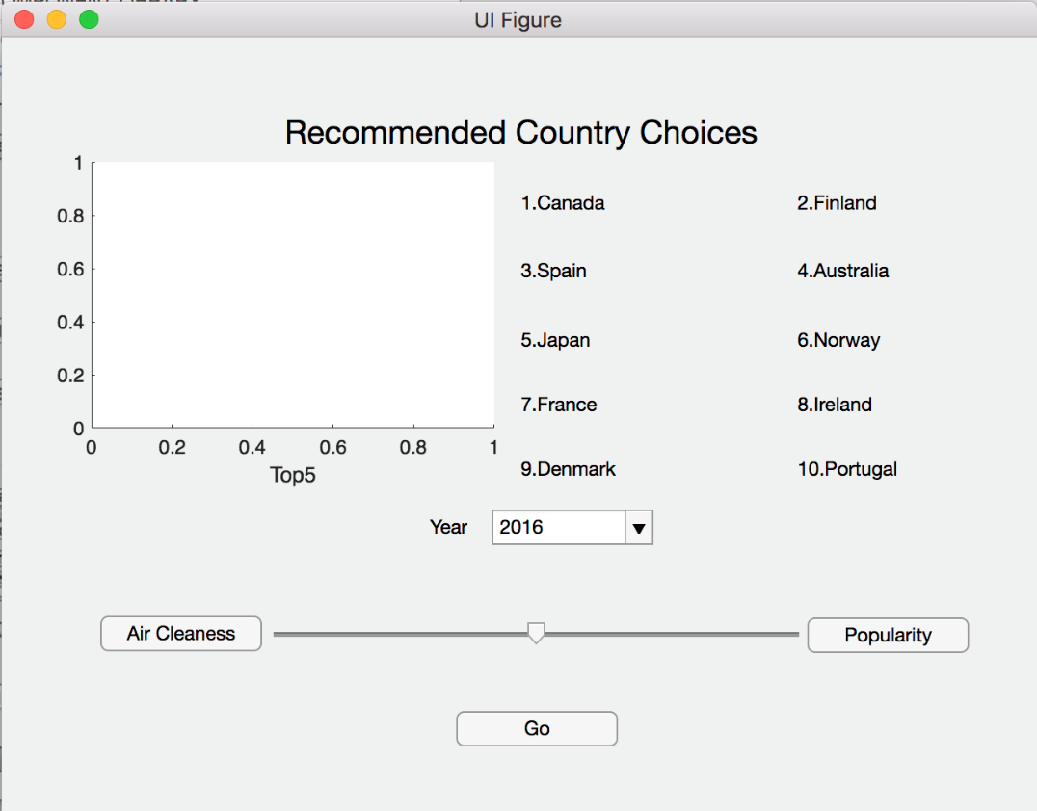

1. The year choosing function:

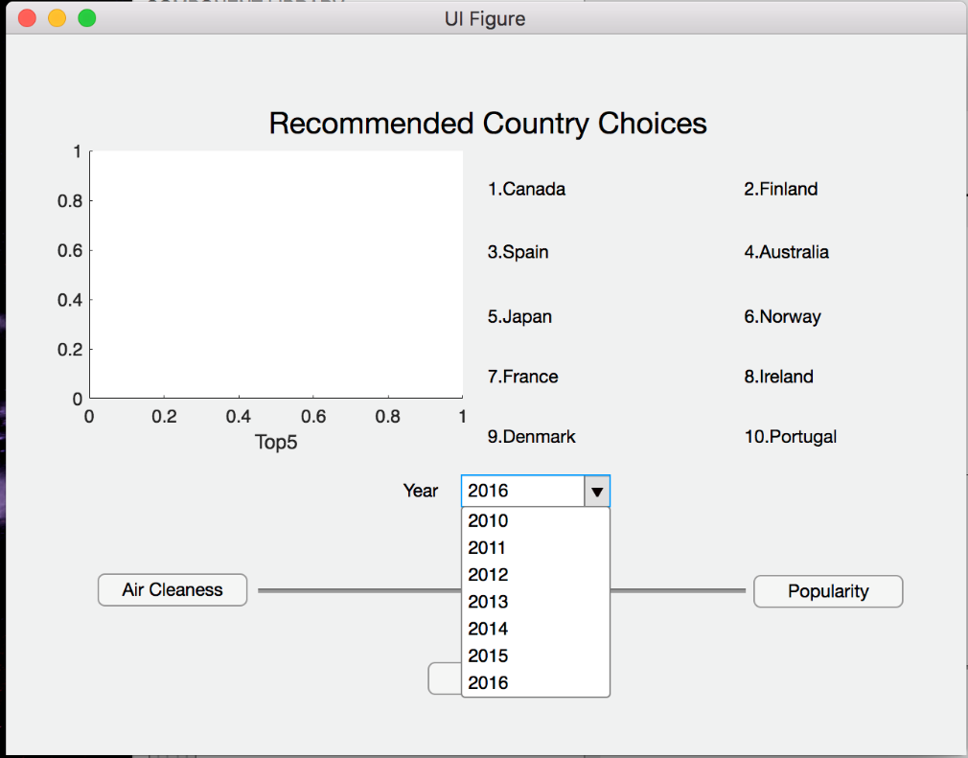As user click the drag down arrow in user input window, the available year will be shown as the picture below. User can choose the year they want the data be ranged in.

1. The slider function:

User can also drag the slider’s arrow to the side he or she favors. (If user prefer air cleanness, drag slider arrow to left and if user prefer popularity, drag slider arrow to the right.)

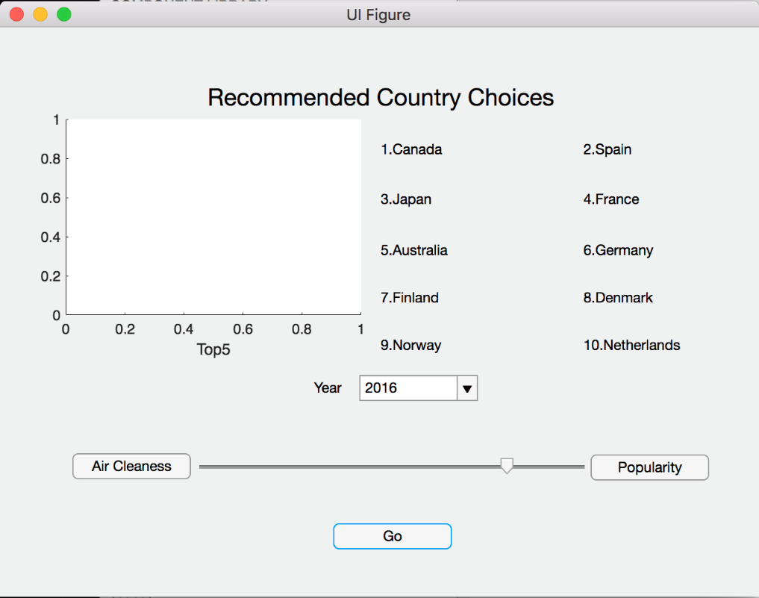

1. The Go button:

After changing the year and slider, click the go button and user will receive our suggestions on the suggestion window on the upper right side.

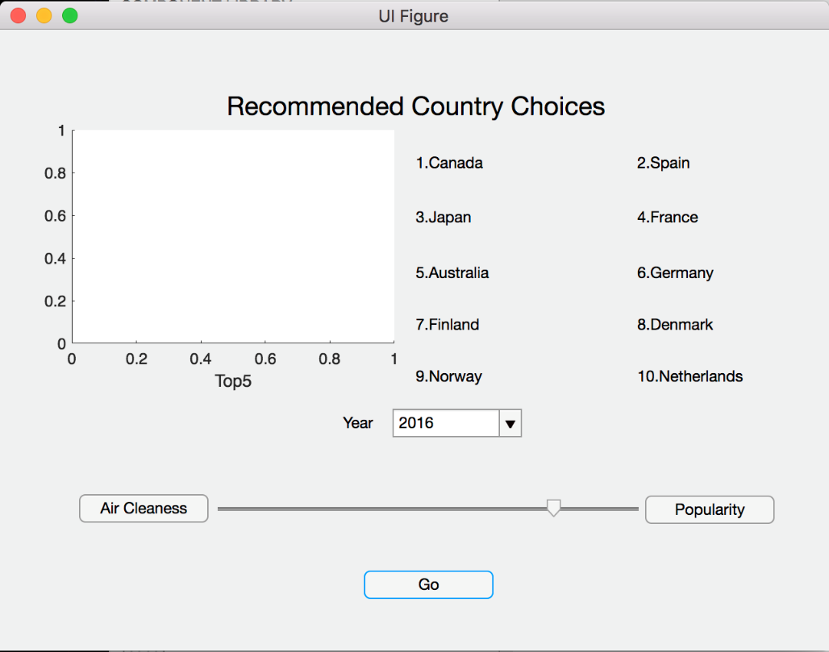

1. The chart function:

If user want more detailed data, it is possible to click the “Air Cleanness” button or “Popularity” button, and then press the “Go” button again, a chart will be generated in the chart portion.

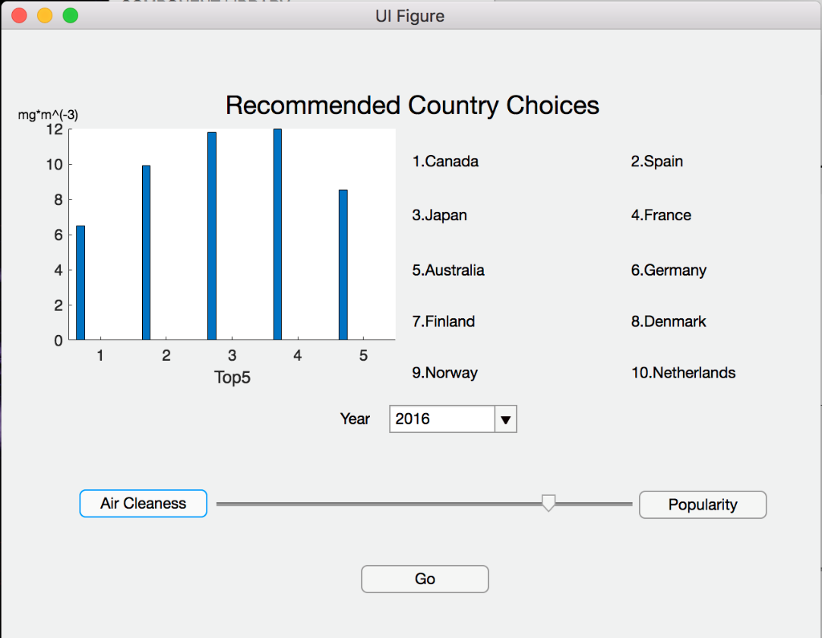

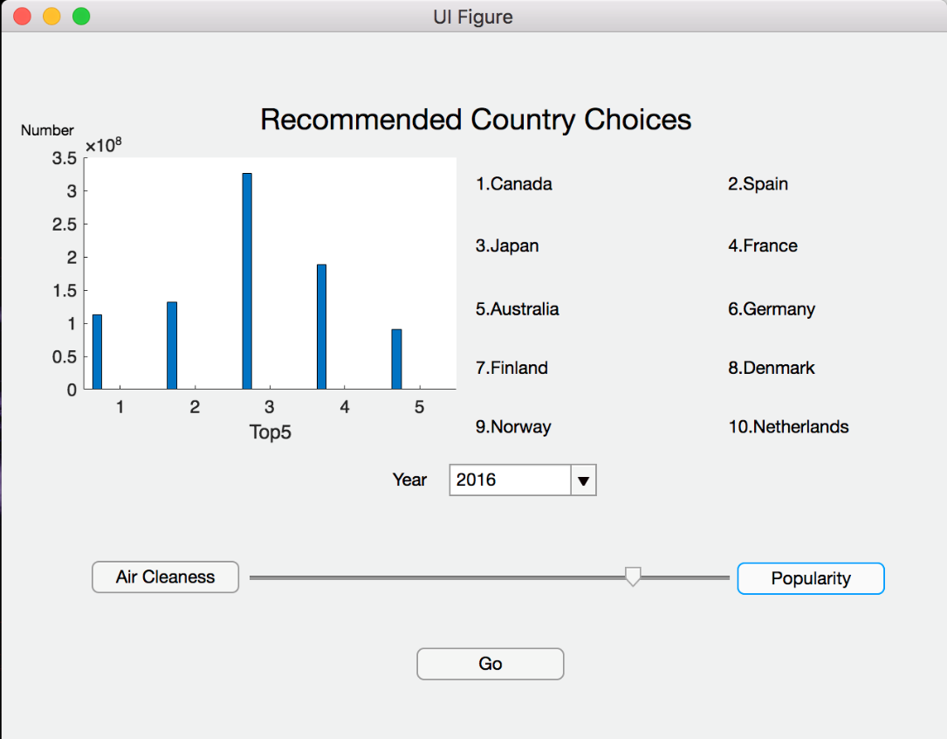

Actual Code:

